Supplementary material for Uncertainty-Aware Fleet Planning for Heavy-Duty Freight in the Transition to Alternative Powertrains
Kenneth J. Martinezª and Styliani Avraamidou^{a*}
ª Department of Chemical and Biological Engineering, University of Wisconsin--Madison, 1415 Engineering Drive, Madison, Wisconsin 53706, USA
* Corresponding Author: avraamidou@wisc.edu

Notation and Scenario Sets
The supplementary material documents the data-generation equations and scenario tables used in the 2030 stochastic case study. The extensive-form stochastic program uses route set $R$, scenario set $Ω$, freight-density classes $G$, owned truck options $E$, truck-copy candidates $U_{e}$, and hired service options $D$. Scenario probabilities satisfy ω∈Ω​πω=1 and are applied once per operating-day scenario, not once per route row.
The first-stage variables are the owned fleet count $x_{e}$ and truck-copy activation $v_{eu}$; they are selected before the operating scenario is known and are shared across all scenarios. After demand, freight composition, and route distance are observed, the scenario-indexed second-stage variables select owned and hired route-cycle counts, pallet assignments, stacking, truck energy use, and off-shift, daytime-depot, and route-associated energy purchases.
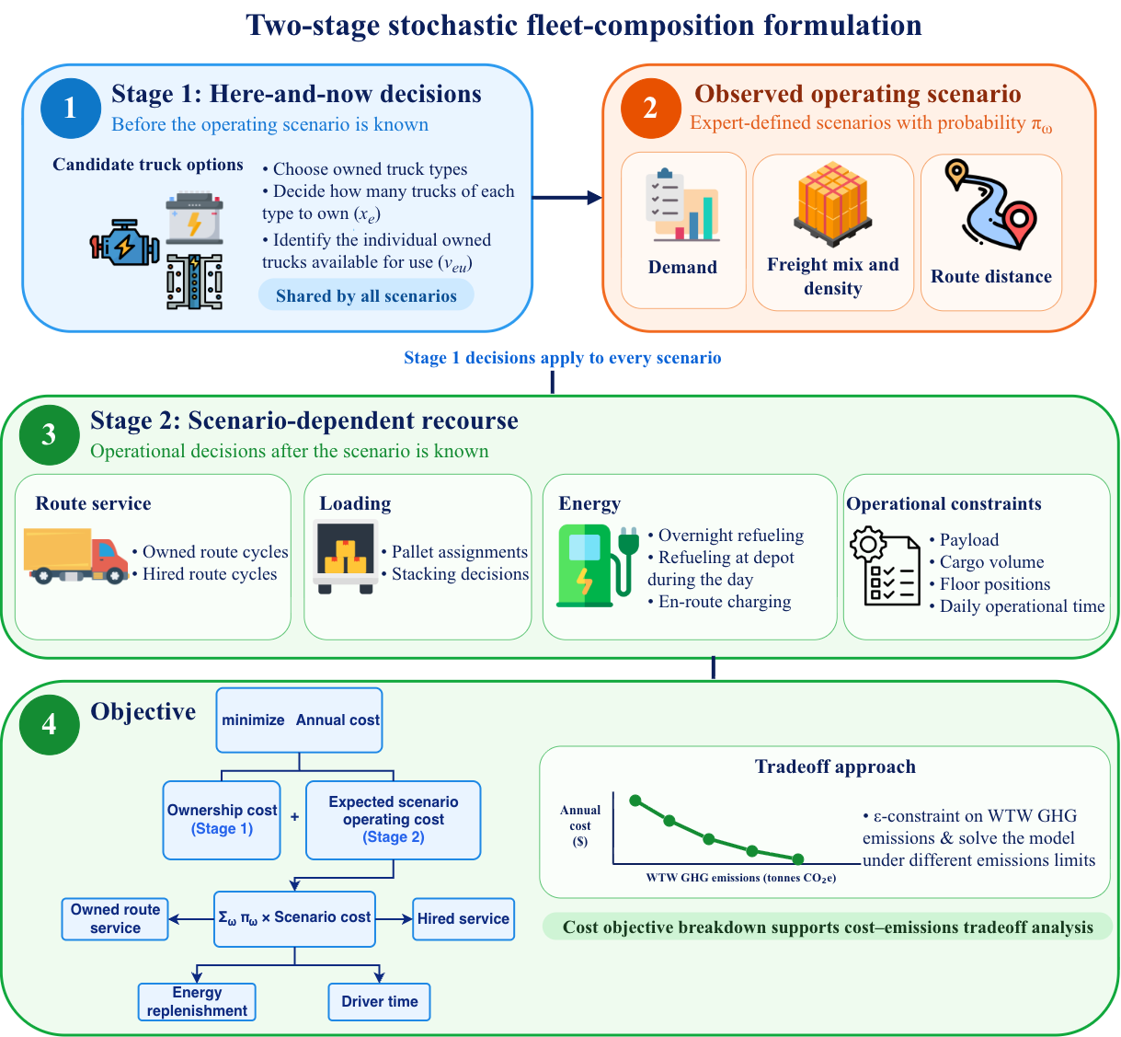
Figure S1: Illustration of the two-stage stochastic fleet-composition model. Fleet acquisition is selected before the operating scenario is observed; route service, freight loading, energy replenishment, and hired service adapt after demand, freight composition, and route distance are realized. The epsilon-constraint method generates the expected-cost--WTW-emissions tradeoff.
Freight-Class Construction
Freight classes are derived from standard pallet geometry and representative freight density. Representative density intervals for NMFC classes 175, 85, and 60 follow the Freightquote density chart [S3]. The pallet footprint is 48 in by 40 in and the cargo height is 45 in, giving
$$V^{pallet}=\frac{48⋅40⋅45}{1728}≈50 {ft}^{3}.$$
For freight class $g$, pallet weight in short tons is
$$w_{g}=\frac{ρ_{g}V^{pallet}}{2000},$$
where ρ_{g} is in lb/ft³. Table S1 summarizes the representative classes.
Table S1: Representative freight-density classes.
Class | Density | Weight | Volume | Stack.
 | (lb/ft³) | (ton/pallet) | (ft³/pallet)
NMFC 175 | 5.0 | 0.1250 | 50 | No
NMFC 85 | 13.5 | 0.3375 | 50 | Yes
NMFC 60 | 32.5 | 0.8125 | 50 | Yes
Route-Time and Distance Scenarios
The stochastic distance model uses route-family-specific short, main, and long distances. Base route-cycle time is
$$T_{rω}^{0}=\frac{L_{rω}}{s_{r}}+t^{dh},$$
where $L_{rω}$ is the scenario-specific route-cycle distance, $s_{r}$ is the route-family average speed, and $t^{dh}=0.5$ h is the hook/drop allowance. Table S2 gives the route families.
Table S2: Route-family distances and base travel-time assumptions.
Route | Short | Main | Long | Speed | Drop/hook
 | (mi) | (mi) | (mi) | (mph) | (h)
route_200 | 100 | 150 | 200 | 30 | 0.5
route_400 | 325 | 400 | 475 | 45 | 0.5
route_600 | 500 | 600 | 700 | 55 | 0.5
Scenario-specific route-cycle distances are assigned from the short, main, and long values in Table S2. The low-light scenario uses short distances on all routes; mixed-medium and low-heavy scenarios use main distances; route-specific surge scenarios use the long distance on the surged route family; regional-long-surge uses long regional and long-haul distances; and cube-peak and weight-peak scenarios use long distances on all routes. These levels determine $L_{rω}$ and $T_{rω}^{0}$ in Eq. (S3).
Throughput-Based Baseline Demand
Baseline demand is constructed from a reference truck-throughput calculation rather than by repeatedly solving the optimization model. For each route,
$$ν_{r}=max\left\{1,floor\left(\frac{H_{r}^{ref}}{T_{r}^{0,main}}\right)\right\},$$
where $ν_{r}$ is route cycles per reference truck per day. Baseline pallets are
$${\overset{‾}{P}}_{r}=round\left(N_{r}^{truck} ν_{r} K_{r}^{ref} η^{load}\right),$$
with load factor $η^{load}=0.85$. Table S3 reports the resulting baseline.
Table S3: Throughput-based baseline pallet demand.
Route | Main mi | $$T^{0}$$ | $$H^{ref}$$ | Cycles | $$K^{ref}$$ | Pallets
route_200 | 150 | 5.50 | 10 | 1 | 12 | 61
route_400 | 400 | 9.39 | 14 | 1 | 26 | 155
route_600 | 600 | 11.41 | 14 | 1 | 26 | 155
Scenario total pallets are computed as
$$P_{rω}=round\left({\overset{‾}{P}}_{r}μ_{rω}\right),$$
where $μ_{rω}$ is the route-scenario demand multiplier. Integer freight-class demands use the floor-plus-largest-remainder rule. Let ${\hat{N}}_{rgω}=P_{rω}s_{rgω}$ and $F_{rgω}=⌊{\hat{N}}_{rgω}⌋$. The residual Rrω=Prω-g​Frgω is assigned by adding one pallet to the $R_{rω}$ classes with the largest fractional remainders ${\hat{N}}_{rgω}-F_{rgω}$. Thus
g∈G​Nrgω=Prω ∀r,ω.
Expert Scenario Tables
Tables S4 and S5 give the scenario design. The first table reports scenario probabilities and route-level demand multipliers; the second reports freight-density composition. Density share triples are ordered as NMFC 175/NMFC 85/NMFC 60. The three route-family columns correspond to local, regional, and long-haul routes, respectively.
Table S4: Expert-scenario probabilities and route-level demand multipliers.
ID | Scenario | Prob. | Local | Reg. | Long
W1 | mixed medium | 0.45 | 1.00 | 1.00 | 1.00
W2 | low light | 0.10 | 0.70 | 0.70 | 0.70
W3 | low heavy | 0.10 | 0.80 | 0.80 | 0.80
W4 | local bulky surge | 0.05 | 2.30 | 0.85 | 0.85
W5 | local heavy surge | 0.05 | 1.90 | 0.90 | 0.90
W6 | regional surge | 0.05 | 0.85 | 2.40 | 0.85
W7 | long-haul surge | 0.05 | 0.80 | 0.80 | 2.70
W8 | regional–long-haul surge | 0.05 | 0.75 | 2.20 | 2.30
W9 | cube peak | 0.05 | 1.80 | 1.60 | 1.40
W10 | weight peak | 0.05 | 1.50 | 2.00 | 2.40

Table S5: Freight-density composition by scenario and route family. Scenario IDs follow Table S4; shares are NMFC 175/85/60.
ID | Local | Reg. | Long
W1 | 0.50/0.30/0.20 | 0.30/0.40/0.30 | 0.15/0.35/0.50
W2 | 0.70/0.20/0.10 | 0.55/0.30/0.15 | 0.35/0.40/0.25
W3 | 0.25/0.40/0.35 | 0.15/0.35/0.50 | 0.10/0.25/0.65
W4 | 0.75/0.20/0.05 | 0.30/0.40/0.30 | 0.15/0.35/0.50
W5 | 0.15/0.30/0.55 | 0.30/0.40/0.30 | 0.15/0.35/0.50
W6 | 0.50/0.30/0.20 | 0.10/0.35/0.55 | 0.15/0.35/0.50
W7 | 0.50/0.30/0.20 | 0.30/0.40/0.30 | 0.05/0.20/0.75
W8 | 0.50/0.30/0.20 | 0.05/0.25/0.70 | 0.05/0.25/0.70
W9 | 0.75/0.20/0.05 | 0.60/0.30/0.10 | 0.50/0.35/0.15
W10 | 0.10/0.30/0.60 | 0.05/0.25/0.70 | 0.05/0.15/0.80
Truck Option Screening and Hired-Service Cost Construction
The owned option set contains 21 truck options after filtering the 2030 techno-economic data. Local service can use Class 7 day cabs with 100 or 200 mile range tiers and Class 8 day cabs with 150 or 300 mile range tiers. Regional and long-haul service can use Class 8 sleeper trucks with 300 or 600 mile range tiers. Candidate powertrains are DICET, BET, and HFCET–350bar with gray, blue, or green hydrogen pathways. The underlying vehicle techno-economic and performance inputs follow the prior heavy-duty-powertrain study [S1], which uses the T3CO framework [S2].
Hired service is modeled as an all-in route-cycle cost. Regular local spot service is available with Class 7 DICET and BET trucks on the local route. Emergency diesel service uses a Class 8 sleeper DICET 600-mile option and is available on all route families. Emergency green-HFCET service uses a Class 7 day option on the local route and a Class 8 sleeper option on the regional and long-haul route families. Let $τ_{d}^{S1}$ be the S1 TCO value for hired option $d$ in USD/ton-mile and let ${\tilde{W}}_{dr}$ be the representative payload in short tons. The hired route-cycle price is
$$C_{drω}^{h}=α_{d}τ_{d}^{S1}{\tilde{W}}_{dr}L_{rω}, ρ_{drω}^{h}=\frac{C_{drω}^{h}}{L_{rω}},$$
where $α_{d}=2$ for regular local hired service and $α_{d}=3$ for emergency service.
Table S6: Hired-service tiers used in the stochastic recourse model.
Tier | Class/cab | Powertrain | Routes | Mult.
Regular local | Class 7 day, 200 mi | DICET | Local | 2.0
Regular local | Class 7 day, 200 mi | BET | Local | 2.0
Emergency | Class 8 sleeper, 600 mi | DICET | All | 3.0
Emergency | Class 7 day, 100 mi | HFCET green | Local | 3.0
Emergency | Class 8 sleeper, 300 mi | HFCET green | Reg./long | 3.0
Robustness and Sensitivity Analyses
The central case uses the 2030 Program Success technology future and medium energy prices. The following tests vary one assumption family at a time while retaining the formulation, truck-option filter, ten operating scenarios, route definitions, demand multipliers, and emissions accounting. Program Success and No Program are treated as alternative exogenous technology futures rather than daily operating scenarios.
Technology-development future
Both futures retain the same 21 owned options. Relative to No Program, Program Success reduces median annualized fixed cost by 10.17%, non-energy mileage cost by 17.48%, no-load energy intensity by 4.82%, payload energy intensity by 8.20%, and WTW emissions intensity by 8.23%; median payload increases by 2.52%.
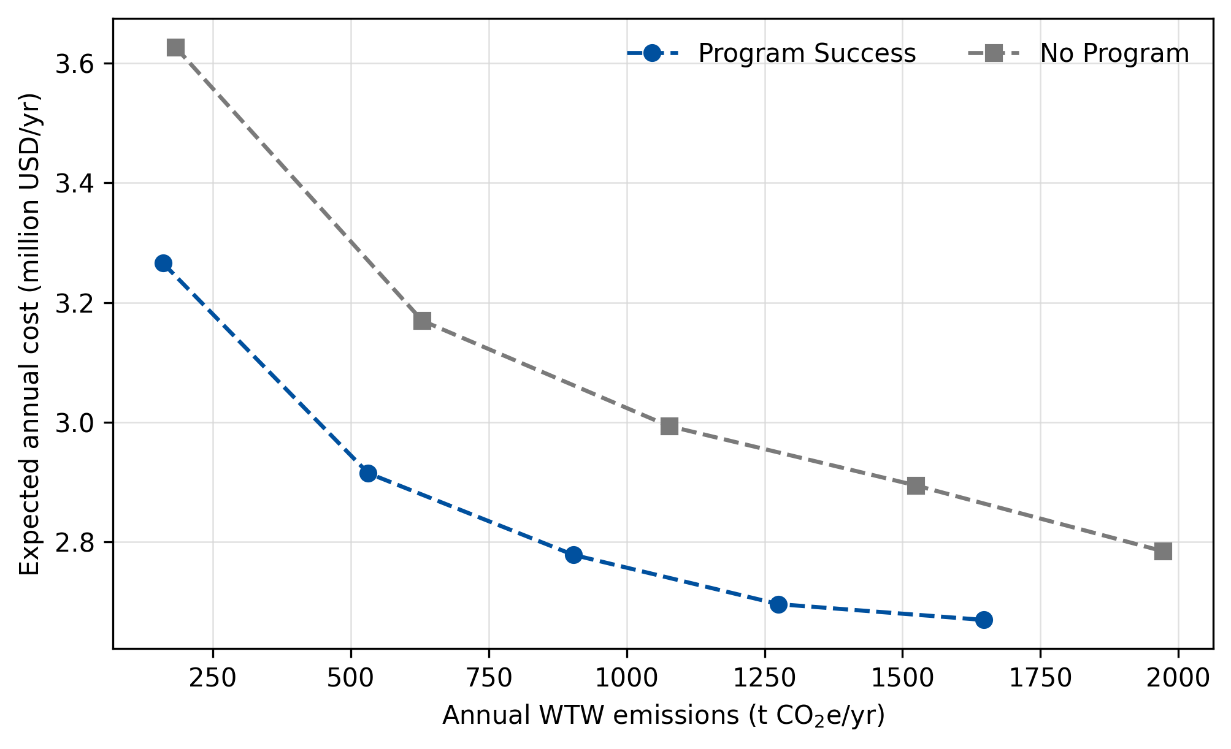
Figure S2: Cost-emissions Pareto frontiers under the Program Success and No Program 2030 technology futures.
Delayed technology progress shifts the frontier upward and to the right. The No Program no-cap solution costs $2.785 million/yr and emits 1,972 t CO2e/yr, compared with $2.670 million/yr and 1,647 t CO2e/yr under Program Success. The No Program minimum-emissions endpoint costs $3.627 million/yr at 182 t CO2e/yr, compared with $3.266 million/yr at 160 t CO2e/yr. The two middle No Program points retain feasible incumbents at 1.01% and 1.96% gaps after extended bound-focused solves; the other points meet the 1% target.
Technology future and energy prices
Table S7 evaluates the repository low, medium, and high energy-price cases under both technology futures at the fixed 1,275 t CO2e/yr limit. Fleet counts are reported as DICET/BET/HFCET.
Future | Price | Cost (M$/yr) | Owned | Fleet D/B/H | Gap (%)
Program | Low | 2.526 | 21 | 14/3/4 | 1.00
Program | Med | 2.696 | 21 | 14/3/4 | 0.97
Program | High | 2.944 | 22 | 12/8/2 | 1.22
No program | Low | 2.757 | 22 | 14/3/5 | 2.01
No program | Med | 2.953 | 22 | 14/3/5 | 1.95
No program | High | 3.206 | 26 | 15/11/0 | 2.03
Table S7: Technology-future and energy-price sensitivity at 1,275 t CO2e/yr.
Energy-Service Equations
Owned route energy consumption is affine in empty route cycles and realized payload ton-miles:
χeurωo=θer0Lrωneurωo+θerPLrωg​wgqeurgωo.
The no-load term $θ_{er}^{0}$ and payload slope $θ_{er}^{P}$ are computed within retained truck-option groups using range-tier-specific loaded and tare energy-intensity data when available. The fitted slope is the incremental loaded-minus-tare energy per payload ton-mile.
For BETs, pre-window depot charging is limited to 70% of battery storage and does not consume dispatchable operating time:
$$M_{euω}^{p}≤0.70C_{e}^{store}v_{eu}.$$
Daytime depot charging and route-associated megawatt charging are both allowed as recourse modes and consume truck and driver time. For DICET and HFCET options, all refueling needed for the operating day consumes dispatchable truck and driver time. The truck-copy daily energy balance is
r​χeurωo≤Meuωpζep+Meuωdayζeday+r​Meurωrngζerrng.
Route-associated service is also constrained by onboard route-cycle capability:
$$χ_{eurω}^{o}≤B_{e}^{cyc}n_{eurω}^{o}+\frac{M_{eurω}^{rng}}{ζ_{er}^{rng}}.$$
No fixed non-energy stop overhead is included because the aggregate trip-count model does not schedule physical stop counts or station locations.
Truck-copy operating time is
r​Trω0neurωo+λedayMeuωday+r​λerrngMeurωrng≤Heveu.
The dispatch windows used in the optimization are 10 h for day cabs and 14 h for sleeper trucks. These values are case-study operating assumptions and are not modifications of the underlying TEA data.
Emissions Accounting
WTW emissions are computed from realized ton-miles, not from purchased energy. Scenario emissions are
Eωo=e,u,r​γeoLrωg​wgqeurgωo,Eωh=d,r​γdhLrωg​wgqdrgωh.
The annual expected emissions cap is
Dω∈Ω​πωEωo+Eωh≤ε.
References
[S1] Martinez, K.; Wagh, R.; Avraamidou, S. Alternative Heavy-Duty Powertrains: The Economic and Environmental Sustainability Impacts of Logistics and Autonomy. SSRN, July 10, 2026. https://doi.org/10.2139/ssrn.7095980.
[S2] Lustbader, J.; Panneer Selvam, H.; Bennion, K.; Payne, G.; Hunter, C.; Penev, M.; Brooker, A.; Baker, C.; Birky, A.; Zhang, C.; Carow, K. T3CO (Transportation Technology Total Cost of Ownership) Open Source [SWR-21-54]. Computer software, 2024. https://doi.org/10.11578/dc.20240806.4.
[S3] Freightquote by C.H. Robinson. Freight Class Calculator & Chart. https://www.freightquote.com/how-to-ship-freight/freight-class-density-calculator/ (accessed September 19, 2026).
© 2027 by the authors. Licensed to PSEcommunity.org and PSE Press under the Creative Commons CC-BY-SA 4.0 license.

