Supporting Information for: Beyond Tennessee Eastman: Benchmarking Deep Anomaly Detection on Real-World Pilot-Scale Continuous Distillation Data
Fabian. Hartung^{a,c†}, Aparna. Muraleedharan.^{b†}, Marius.Kloftª ,and Jakob.Burger^{b}*
ª RPTU Kaiserslautern, Department of Machine Learning, Kaiserslautern, Germany
^{b} Technical University of Munich, Laboratory for Chemical Process Engineering, Straubing, Germany
* Corresponding Author: burger@tum.de.
† These authors contributed equally to this work.

Figure 1 represents TEP data from the head pressure sensor (xmeas_7) during a faulty run. The entire run is considered faulty (testing_07.csv). It can be observed that from around 170 sample index (x-axis), the column head pressure suddenly drops sharply, followed immediately by a large overshoot where the pressure rises significantly above the nominal operating range. Subsequently, the system exhibits a damped oscillatory transient, characterized by alternating peaks and troughs with gradually decreasing amplitude. After the transient phase, the pressure settles into a new steady regime, with fluctuations comparable to those observed before fault introduction but around a shifted mean level.

Figure 2 represents plant steady state data from the head pressure sensor during a faulty run (Water Run - operating point 001 - test_anormal_experiment_001). The shaded red region indicates the anomalous time interval. Prior to the shaded interval, the pressure signal fluctuates around a stable nominal operating level. Within the highlighted anomaly window, the signal exhibits a systematic deviation from the nominal regime, characterized by a decrease in pressure and increased variability. After the anomalous period, the pressure recovers and stabilizes, returning to a level and variance comparable to the pre-anomaly operation.

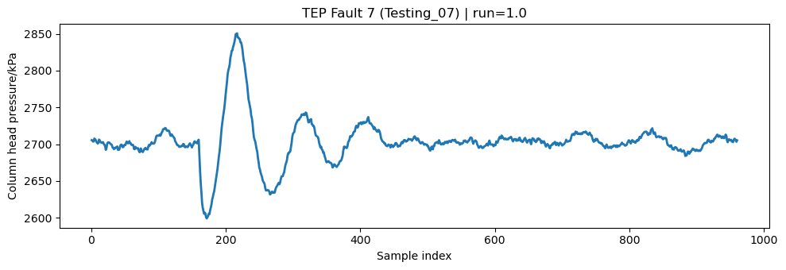
Figure 1: Head pressure sensor measurements during a faulty TEP run

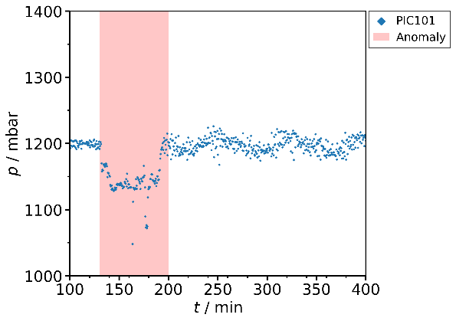
Figure 2: Head pressure sensor measurements during a faulty water run

Figure 3 represents TEP data from the head pressure sensor (xmeas_7) during a normal run (testing_00.csv). Column head pressure during normal operation in the TEP dataset, illustrating typical closed-loop variability in the absence of faults. Figure 4 represents plant steady state data from the head pressure sensor during a normal run (OME run - operating point 002 - train_normal_experiment_001), showing stable behavior with small stochastic fluctuations.

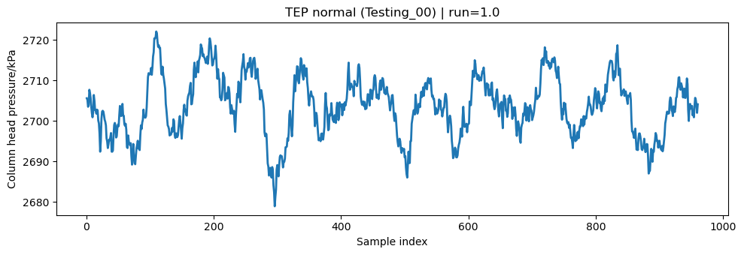
Figure 3: Head pressure sensor measurements during a normal TEP run

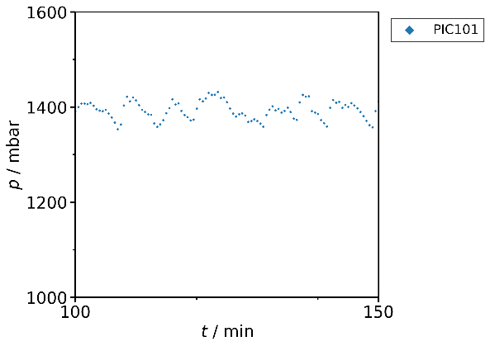
Figure 4: Head pressure sensor measurements during a normal run with OME

Tables 1, 2, and 3 show the performance of the AD method types on the Butanol (n-butanol-water system), OME, and water datasets, respectively.

Table 1: Type-wise performance on Butanol dataset.

Type | Mean F1 | Rank (F1) | Mean AUPRC | Rank (AUPRC)
Hybrid | 0.577 | 1.00 | 0.340 | 6.00
Baseline | 0.557 | 2.00 | 0.401 | 1.00
Prediction | 0.550 | 3.00 | 0.381 | 4.00
Generative VAE | 0.534 | 4.00 | 0.383 | 2.00
Reconstruction | 0.515 | 5.00 | 0.382 | 3.00
Generative GAN | 0.512 | 6.00 | 0.353 | 5.00

Table 2: Type-wise performance on OME dataset.

Type | Mean F1 | Rank (F1) | Mean AUPRC | Rank (AUPRC)
Generative VAE | 0.684 | 1.00 | 0.518 | 1.00
Hybrid | 0.649 | 4.00 | 0.475 | 5.00
Baseline | 0.651 | 3.00 | 0.492 | 2.00
Generative GAN | 0.657 | 2.00 | 0.489 | 3.00
Prediction | 0.639 | 5.00 | 0.466 | 6.00
Reconstruction | 0.549 | 6.00 | 0.497 | 2.00

Table 3: Type-wise performance on Water dataset.

Type | Mean F1 | Rank (F1) | Mean AUPRC | Rank (AUPRC)
Hybrid | 0.464 | 1.00 | 0.276 | 1.00
Prediction | 0.457 | 2.00 | 0.198 | 5.00
Baseline | 0.438 | 3.00 | 0.264 | 2.00
Generative VAE | 0.434 | 4.00 | 0.163 | 6.00
Generative GAN | 0.432 | 5.00 | 0.233 | 3.00
Reconstruction | 0.381 | 6.00 | 0.205 | 4.00

Table 4 gives the mean performance of the different AD method types across Butanol, OME and Water datasets.

Table 4: Type-wise mean performance across Butanol, OME, and Water (treated as dataset).

Type | Mean F1 | Rank (F1) | Mean AUPRC | Rank (AUPRC)
Hybrid | 0.564 | 1.00 | 0.364 | 2.00
Generative VAE | 0.550 | 2.00 | 0.355 | 5.00
Prediction | 0.549 | 3.00 | 0.348 | 6.00
Baseline | 0.548 | 4.00 | 0.384 | 1.00
Generative GAN | 0.534 | 5.00 | 0.359 | 4.00
Reconstruction | 0.482 | 6.00 | 0.362 | 3.00

Table 5 gives the performance of the different method types on the TEP dataset.
Table 5: Type-wise performance on TEP dataset.

Type | Mean F1 | Rank (F1) | Mean AUPRC | Rank (AUPRC)
Generative VAE | 0.900 | 1.00 | 0.951 | 1.00
Prediction | 0.881 | 2.00 | 0.912 | 3.00
Hybrid | 0.860 | 3.00 | 0.849 | 6.00
Generative GAN | 0.852 | 4.00 | 0.874 | 5.00
Baseline | 0.848 | 5.00 | 0.882 | 4.00
Reconstruction | 0.822 | 6.00 | 0.922 | 2.00

Tables 6, 7, and 8 give the performance of the different AD methods on the butanol, OME, and water datasets, respectively.

Table 6: Performance on Butanol dataset.

Method | Type | F1-Score | Rank (F1) | AUPRC | Rank (AUPRC)
LSTM-2S2-P [48] | P | 0.624 | 1 | 0.390 | 9
LSTM-AE-OC-SVM [40] | H | 0.600 | 2 | 0.331 | 29
Dense-AE [28] | R | 0.596 | 3 | 0.377 | 18
LSTM-MAX-AE [39] | R | 0.594 | 4 | 0.373 | 21
NCAD [51] | H | 0.593 | 5 | 0.284 | 30
WMD-AD [56] | B | 0.588 | 6 | 0.445 | 1
LSTM-AE [29] | R | 0.588 | 7 | 0.375 | 20
THOC [49] | H | 0.585 | 8 | 0.360 | 26
LSTM-DVAE [35] | V | 0.559 | 9 | 0.401 | 2
OOS-AD [55] | B | 0.557 | 10 | 0.392 | 6
TCN-S2S-AE [27] | R | 0.544 | 11 | 0.391 | 7
IQR-AD [54] | B | 0.543 | 12 | 0.392 | 5
PCA-AD [53] | B | 0.540 | 13 | 0.376 | 19
USAD [36] | R | 0.539 | 14 | 0.391 | 8
OmniAnomaly [33] | V | 0.537 | 15 | 0.399 | 3
TCN-S2S-P [38] | P | 0.535 | 16 | 0.379 | 15
GMM-GRU-VAE [37] | V | 0.534 | 17 | 0.387 | 10
LSTM-P [30] | P | 0.534 | 18 | 0.371 | 22
SIS-VAE [34] | V | 0.532 | 19 | 0.385 | 12
MTAD-GAT [45] | H | 0.532 | 20 | 0.386 | 11
GDN [47] | P | 0.529 | 21 | 0.382 | 14
DeepANT/TCN-P [46] | P | 0.527 | 22 | 0.384 | 13
LSTM-VAE [32] | V | 0.527 | 23 | 0.363 | 25
LSTM-VAE-GAN [52] | G | 0.523 | 24 | 0.367 | 23
STGAT-MAD [43] | R | 0.520 | 25 | 0.377 | 17
Donut [31] | V | 0.513 | 26 | 0.365 | 24
Mad-GAN [44] | G | 0.512 | 27 | 0.338 | 28
TadGAN [42] | G | 0.501 | 28 | 0.355 | 27
GenAD [41] | R | 0.446 | 29 | 0.397 | 4
AnomalyTransformer [50] | R | 0.291 | 30 | 0.377 | 16

Table 7: Performance on OME dataset.

Method | Type | F1-Score | Rank (F1) | AUPRC | Rank (AUPRC)
LSTM-VAE [32] | V | 0.718 | 1 | 0.547 | 2
LSTM-DVAE [35] | V | 0.714 | 2 | 0.537 | 3
TadGAN [42] | G | 0.705 | 3 | 0.529 | 5
MTAD-GAT [45] | H | 0.686 | 4 | 0.531 | 4
OmniAnomaly [33] | V | 0.677 | 5 | 0.527 | 6
THOC [49] | H | 0.676 | 6 | 0.479 | 21
GMM-GRU-VAE [37] | V | 0.670 | 7 | 0.505 | 7
WMD-AD [56] | B | 0.666 | 8 | 0.504 | 9
SIS-VAE [34] | V | 0.665 | 9 | 0.497 | 13
Dense-AE [28] | R | 0.659 | 10 | 0.493 | 14
Donut [31] | V | 0.658 | 11 | 0.497 | 12
IQR-AD [54] | B | 0.658 | 12 | 0.483 | 15
TCN-S2S-P [38] | P | 0.652 | 13 | 0.475 | 23
DeepANT/TCN-P [46] | P | 0.651 | 14 | 0.499 | 11
STGAT-MAD [43] | R | 0.651 | 15 | 0.502 | 10
OOS-AD [55] | B | 0.649 | 16 | 0.482 | 16
LSTM-P [30] | P | 0.645 | 17 | 0.459 | 26
Mad-GAN [44] | G | 0.642 | 18 | 0.482 | 17
LSTM-AE [29] | R | 0.642 | 19 | 0.469 | 24
TCN-S2S-AE [27] | R | 0.641 | 20 | 0.504 | 8
LSTM-MAX-AE [39] | R | 0.635 | 21 | 0.479 | 18
PCA-AD [53] | B | 0.632 | 22 | 0.479 | 19
GDN [47] | P | 0.632 | 23 | 0.475 | 22
LSTM-VAE-GAN [52] | G | 0.625 | 24 | 0.456 | 27
USAD [36] | R | 0.620 | 25 | 0.452 | 28
NCAD [51] | H | 0.618 | 26 | 0.461 | 25
LSTM-AE-OC-SVM [40] | H | 0.615 | 27 | 0.427 | 29
LSTM-2S2-P [48] | P | 0.614 | 28 | 0.420 | 30
GenAD [41] | R | 0.331 | 29 | 0.597 | 1
AnomalyTransformer [50] | R | 0.215 | 30 | 0.479 | 20

Table 8: Performance on Water dataset.

Method | Type | F1-Score | Rank (F1) | AUPRC | Rank (AUPRC)
LSTM-2S2-P [48] | P | 0.531 | 1 | 0.323 | 1
LSTM-AE-OC-SVM [40] | H | 0.512 | 2 | 0.311 | 2
MTAD-GAT [45] | H | 0.478 | 3 | 0.298 | 3
LSTM-AE [29] | R | 0.472 | 4 | 0.235 | 12
PCA-AD [53] | B | 0.463 | 5 | 0.216 | 13
LSTM-P [30] | P | 0.461 | 6 | 0.179 | 19
TadGAN [42] | G | 0.449 | 7 | 0.288 | 6
OOS-AD [55] | B | 0.447 | 8 | 0.289 | 4
THOC [49] | H | 0.443 | 9 | 0.250 | 10
Dense-AE [28] | R | 0.438 | 10 | 0.182 | 18
STGAT-MAD [43] | R | 0.438 | 11 | 0.191 | 16
LSTM-MAX-AE [39] | R | 0.438 | 12 | 0.183 | 17
LSTM-VAE [32] | V | 0.438 | 13 | 0.169 | 22
LSTM-DVAE [35] | V | 0.436 | 14 | 0.169 | 23
TCN-S2S-AE [27] | R | 0.435 | 15 | 0.198 | 15
GDN [47] | P | 0.435 | 16 | 0.168 | 24
OmniAnomaly [33] | V | 0.435 | 17 | 0.177 | 20
GMM-GRU-VAE [37] | V | 0.433 | 18 | 0.163 | 26
WMD-AD [56] | B | 0.433 | 19 | 0.265 | 8
LSTM-VAE-GAN [52] | G | 0.432 | 20 | 0.256 | 9
SIS-VAE [34] | V | 0.431 | 21 | 0.164 | 25
TCN-S2S-P [38] | P | 0.430 | 22 | 0.160 | 28
DeepANT/TCN-P [46] | P | 0.430 | 23 | 0.161 | 27
USAD [36] | R | 0.429 | 24 | 0.172 | 21
Donut [31] | V | 0.428 | 25 | 0.134 | 30
NCAD [51] | H | 0.423 | 26 | 0.246 | 11
Mad-GAN [44] | G | 0.416 | 27 | 0.156 | 29
IQR-AD [54] | B | 0.407 | 28 | 0.288 | 5
AnomalyTransformer [50] | R | 0.294 | 29 | 0.268 | 7
GenAD [41] | R | 0.104 | 30 | 0.213 | 14

Table 9 gives the mean performance of the different AD methods across Butanol, OME, and water datasets.

Table 9: Mean performance across Butanol, OME, and Water datasets.

Method | Type | F1-Score | Rank (F1) | AUPRC | Rank (AUPRC)
Dense-AE [28] | R | 0.564 | 7.67 | 0.351 | 16.67
THOC [49] | H | 0.568 | 7.67 | 0.363 | 19.00
LSTM-DVAE [35] | V | 0.570 | 8.33 | 0.369 | 9.33
MTAD-GAT [45] | H | 0.565 | 9.00 | 0.405 | 6.00
LSTM-2S2-P [48] | P | 0.590 | 10.00 | 0.378 | 13.33
LSTM-AE [29] | R | 0.567 | 10.00 | 0.360 | 18.67
LSTM-AE-OC-SVM [40] | H | 0.576 | 10.33 | 0.356 | 20.00
WMD-AD [56] | B | 0.562 | 11.00 | 0.405 | 6.00
OOS-AD [55] | B | 0.551 | 11.33 | 0.388 | 8.67
LSTM-VAE [32] | V | 0.561 | 12.33 | 0.360 | 16.33
LSTM-MAX-AE [39] | R | 0.556 | 12.33 | 0.345 | 18.67
OmniAnomaly [33] | V | 0.550 | 12.33 | 0.368 | 9.67
TadGAN [42] | G | 0.552 | 12.67 | 0.391 | 12.67
PCA-AD [53] | B | 0.545 | 13.33 | 0.357 | 17.00
LSTM-P [30] | P | 0.547 | 13.67 | 0.336 | 22.33
GMM-GRU-VAE [37] | V | 0.546 | 14.00 | 0.352 | 14.33
TCN-S2S-AE [27] | R | 0.540 | 15.33 | 0.364 | 10.00
SIS-VAE [34] | V | 0.543 | 16.33 | 0.349 | 16.67
TCN-S2S-P [38] | P | 0.539 | 17.00 | 0.338 | 22.00
STGAT-MAD [43] | R | 0.536 | 17.00 | 0.357 | 14.33
IQR-AD [54] | B | 0.536 | 17.33 | 0.388 | 8.33
NCAD [51] | H | 0.545 | 19.00 | 0.330 | 22.00
DeepANT/TCN-P [46] | P | 0.536 | 19.67 | 0.348 | 17.00
GDN [47] | P | 0.532 | 20.00 | 0.342 | 20.00
Donut [31] | V | 0.533 | 20.67 | 0.332 | 22.00
USAD [36] | R | 0.529 | 21.00 | 0.338 | 19.00
LSTM-VAE-GAN [52] | G | 0.527 | 22.67 | 0.360 | 19.67
Mad-GAN [44] | G | 0.523 | 24.00 | 0.325 | 24.67
GenAD [41] | R | 0.294 | 29.33 | 0.402 | 6.33
AnomalyTransformer [50] | R | 0.267 | 29.67 | 0.375 | 14.33

Table 10 gives the performance of the different AD methods on the TEP dataset

Table 10: Performance on TEP dataset.

Method | Type | F1-Score | Rank (F1) | AUPRC | Rank (AUPRC)
LSTM-VAE [32] | V | 0.911 | 1 | 0.961 | 1
LSTM-P [30] | P | 0.906 | 2 | 0.952 | 5
OmniAnomaly [33] | V | 0.906 | 3 | 0.956 | 2
TCN-S2S-P [38] | P | 0.904 | 4 | 0.951 | 6
LSTM-AE [29] | R | 0.904 | 5 | 0.955 | 3
GMM-GRU-VAE [37] | V | 0.902 | 6 | 0.946 | 9
LSTM-DVAE [35] | V | 0.902 | 7 | 0.954 | 4
TCN-S2S-AE [27] | R | 0.900 | 8 | 0.949 | 7
DeepANT/TCN-P [46] | P | 0.900 | 9 | 0.940 | 13
USAD [36] | R | 0.894 | 10 | 0.946 | 10
SIS-VAE [34] | V | 0.891 | 11 | 0.944 | 12
Donut [31] | V | 0.886 | 12 | 0.944 | 11
MTAD-GAT [45] | H | 0.885 | 13 | 0.939 | 15
LSTM-MAX-AE [39] | R | 0.880 | 14 | 0.940 | 14
Dense-AE [28] | R | 0.878 | 15 | 0.931 | 16
GDN [47] | P | 0.874 | 16 | 0.927 | 18
STGAT-MAD [43] | R | 0.870 | 17 | 0.931 | 17
Mad-GAN [44] | G | 0.866 | 18 | 0.919 | 20
PCA-AD [53] | B | 0.863 | 19 | 0.921 | 19
THOC [49] | H | 0.859 | 20 | 0.902 | 22
LSTM-VAE-GAN [52] | G | 0.856 | 21 | 0.906 | 21
NCAD [51] | H | 0.850 | 22 | 0.699 | 30
IQR-AD [54] | B | 0.849 | 23 | 0.897 | 23
LSTM-AE-OC-SVM [40] | H | 0.847 | 24 | 0.858 | 25
OOS-AD [55] | B | 0.841 | 25 | 0.874 | 24
WMD-AD [56] | B | 0.838 | 26 | 0.834 | 26
TadGAN [42] | G | 0.834 | 27 | 0.796 | 27
LSTM-2S2-P [48] | P | 0.821 | 28 | 0.792 | 28
GenAD [41] | R | 0.756 | 29 | 0.947 | 8
AnomalyTransformer [50] | R | 0.497 | 30 | 0.779 | 29

Table 11 gives the AUPRC statistics for the different scenarios across all evaluated AD methods

Table 11: Dataset-level AUPRC statistics across all evaluated AD methods showing average, minimal, and maximal AUPRC, and the span

AUPRC: | average | min | max | ∆
Butanol | 0.376 | 0.284 | 0.445 | 0.161
OME | 0.491 | 0.420 | 0.597 | 0.177
Water | 0.216 | 0.134 | 0.323 | 0.189
Average | 0.361 | 0.325 | 0.405 | 0.080
TEP | 0.906 | 0.699 | 0.961 | 0.262

