Synergistic integration of direct air capture in bioenergy systems
Nor Syuriaty Jaafarª, Norhuda Abdul Manaf^{a,b*}, Noor Fatina Emelin Nor Fadzilª, and Nilay Shah^{b*},
ª Department of Chemical and Environmental Engineering, Malaysia-Japan International Institute of Technology (MJIIT), Universiti Teknologi Malaysia, Kuala Lumpur, Malaysia
^{b} Department of Chemical Engineering, Imperial College London, SW7 2AZ, United Kingdom
* Corresponding Author: norhuda.kl@utm.my, n.shah@imperial.ac.uk

Appendix S1: Aspen Plus simulation flowsheet of biomass gasification combined cycle systems for simultaneous power and hydrogen production coupled with DAC (BG-PH₂-DAC).
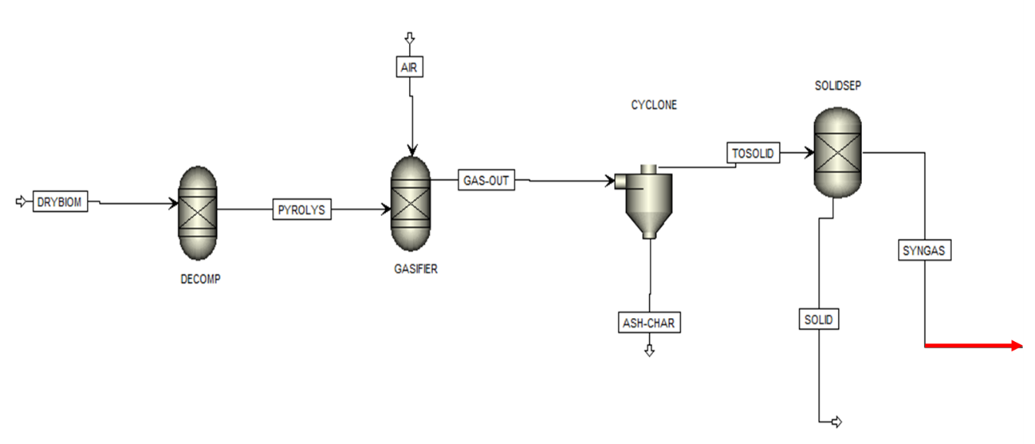
Figure 1: Aspen Plus simulation flowsheet of biomass gasification for syngas production.

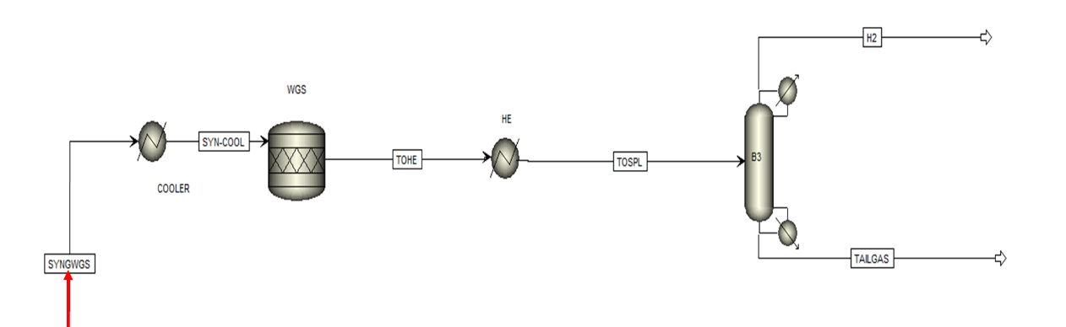
Figure 2: Aspen Plus simulation flowsheet of water gas shift for high purity hydrogen.

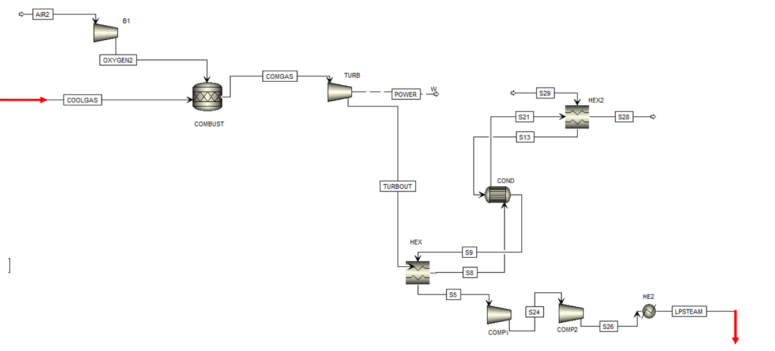
Figure 3. Aspen Plus simulation flowsheet of the combine cycle power and steam generation.

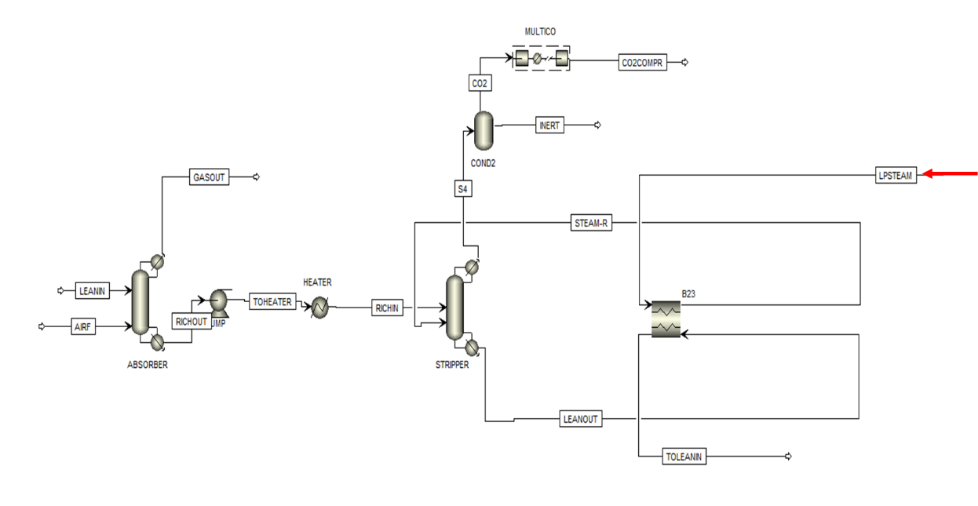
Figure 4. Aspen Plus simulation flowsheet of the DAC with CO₂ compressions.

Appendix S2: Aspen Plus unit operation and parameters for BG-PH₂-DAC
Aspen Plus Unit Operation | Block ID | Description /Operational condition
Biomass gasification
RYield | DECOMP | Temperature: 500°C  Pressure: 1 bar  Converts NC biomass → C, H₂, O₂, N₂, S, ASH
RGibbs | GASIFIER | Temperature: 850°C  Pressure: 1 bar
SSplit | CYCLONE | Removes entrained char/ash
Sep | SOLIDSEP | Final solids removal
Water gas shift reaction
Heater | COOLER | Temperature: 100°C
RStoic | WGS | Temperature: 400°C  Pressure: 1 bar  Stoichiometric reaction  CO + H₂O ⇌ CO₂ + H₂
Heater | HE | Temperature: 400°C
Sep2 | B3 | Final separation stage, work as a scrubber
Combine cycle system generation
Compr | B1 | Compressor  Pressure: 24 bar  Isentropic efficiency: 85%
Rstoic | COMBUST | Temperature: 900°C  Pressure: 1 bar
Compr | TURB | Turbine  Pressure decrease: 10 bar  Isentropic efficiency: 85%
MHeatX | HEX2 | Vapor fraction: 0.0001
HeatX | COND | Temperature: 370°C  Counter-current configuration
MHeatX | HEX | Temperature: 370°C
Compr | COMP1 | Compressor  Pressure: 45.4 bar  Isentropic efficiency: 90%
Compr | COMP2 | Turbine/Expander  Pressure: 5 bar  Isentropic efficiency: 90%
Heater | HE2 | Temperature: 700°C
Direct air capture
MHeatX | B23 | Temperature: 140°C
Radfrac | ABSORBER | Rate based model  Based method: ENRTL-RK  Configuration:  Section packed height: 10 m  Diameter: 4 m  No of stages: 40  Interfacial area factor:1.2  Vapor phase:  Film resistance: Discretized film  Number of discretization point: 5  Liquid phase:  Film resistance: Consider film  Mass transfer coefficient method: Brf-85  Heat transfer coefficient method: Chilton and Colbu  Interfacial area method: Brf-85  Hold-up method: Stichmiair89  Colum description:  Mode: Rating  Internal type: Packed  Packing type: Mellapak250Y (M250Y)  Air inlet stream [1]:  Temperature: 15°C  Pressure: 1 bar  N₂ (78.70%), O₂ (20.50%), H₂O (0.76%), and CO₂ (0.04%)
Pump | PUMP | Pressure: 1.4 bar
Heater | HEATER | Temperature: 80°C
Radfrac | STRIPPER | Rate based model  Based method: ENRTL-RK  Condenser pressure (top stage): 0.7 bar  Partial vapor  Configuration:  Section packed height: 10 m  Diameter: 4 m  No of stages: 40  Interfacial area factor:0.4  Vapor phase:  Film resistance: Discretized film  Number of discretization point: 5  Liquid phase:  Film resistance: Consider film  Mass transfer coefficient method: Brf-85  Heat transfer coefficient method: Chilton and Colburn  Interfacial area method: Brf-85  Hold-up method: Brf-92  Colum description:  Mode: Rating  Internal type: Packed  Packing type: Mellapak250Y (M250Y)
Flash2 | COND2 | Temperature: 200°C  Pressure: 1 bar
Mcompr | MULTICO | Number of stages: 4  Isentropic  Discharge pressure 150 bar

References
1. Deschamps, T., et al. Modeling of Vacuum Temperature Swing Adsorption for Direct Air Capture Using Aspen Adsorption. Clean Technologies, 2022. 4, 258-275 DOI: 10.3390/cleantechnol4020015.

