Particle Swarm Optimization for simultaneous design and optimization of heat pumps considering Mixed Integer problems- Supporting Information
Beatriz C. da Silva ª*, Ana M. Ribeiro ª, Alírio E. Rodrigues ª, Alexandre F.P. Ferreira ª, Diogo Rodrigues ª, Idelfonso B.R. Nogueira ^{b}
ª LSRE-LCM, ALiCE, Faculty of Engineering, University of Porto, Rua Dr. Roberto Frias, 4200-465 Porto, Portugal
^{b} Chemical Engineering Department, Norwegian University of Science and Technology, Sem Sælandsvei 4, Kjemiblokk 5, Trondheim 7491, Norway
* Corresponding Author: up201707213@fe.up.pt.
Base_PSO algorithm
To start the PSO, one must define the number of particles to be evaluated in each iteration ($N_{p}$), the maximum number of iterations to be performed ($N_{it}$) and the side constraints for each variable ($X_{min}$ and $X_{max}$).
In the algorithm, the particle positions ($X$) and velocities (V) are randomly initialized. The positions are evaluated to assess the best position in the swarm ($Y_{globest}$). The particle position is updated according to Equation 1, where $x_{i,n,k}^{*}$ is the candidate position for the variable $n$, particle $i,$ and iteration $k$, $v_{i,n, k}$ is the velocity used to calculate the new position and $x_{i,n,k-1}$ is the previous position of the particle.
$$x_{n,i,k}^{*}=v_{i,n, k}+x_{i,n,k-1}$$ | (1)
After the initial velocity being randomly determined for starting the procedure, the following velocities ($v_{i,n,k}$ for $k>1$) are calculated resorting to Equation 2.
$$v_{i,n,k}=C_{o}v_{i,n,k-1}+C_{1}r_{1}\left(X_{globest}-x_{i,n,k-1}\right)+C_{2}r_{2}(X_{pbest}-x_{i,n,k-1})$$ | (2)
where $X_{globest}$ is the position corresponding to $Y_{globest}$ so far, $X_{pbest}$ is the best position ever achieved by the particle $i$ , $r_{1}$ and $r_{2}$ are two random numbers between 0 and 1, $C_{o}$, $C_{1}$ (2) and $C_{2}$ (2) are acceleration coefficients, and $k$ is the current iteration. $C_{o}$ is variable throughout the optimization, according to Equation 3, where $C_{o,f}$ (0.4) and $C_{0,i}$ (0.9) are the final and initial values of $C_{o}$ ($C_{o,i}>C_{0,f})$.
$$C_{o}=C_{0,i}+ \frac{k-1}{N_{it}-1} (C_{o,f}-C_{0,i})$$ | (3)
With the candidate position calculated, the upper and lower bounds of the variables are enforced. In case a given particle goes beyond the established limits, violation rates ($w_{L}$ and $w_{U}$) are calculated through Equations 4 and 5, aiming to quantify which bound has the higher surpassing.
$$w_{L}=\max_{n}\left(\frac{X_{min}-x_{i,n,k}^{*}}{x_{i,n,k-1}-X_{min}}\right)$$ | (4)
$$w_{U}=\max_{n}\left(\frac{x_{i,n,k}^{*}-X_{max}}{X_{max}-x_{i,n,k-1}}\right)$$ | (5)
Then, the new particle position is determined by Equation 6, where w is the maximum violation rate ($w=\max{(}{w_{L}, w}_{U}$)).
$$x_{i,n,k}=x_{i,n,k-1}+\frac{x_{i,n,k}^{*}-x_{i,n,k-1}}{1+w}$$ | (6)
When the final iteration is completed, the global optimum of the swarm is considered the global optimum of the problem.
The Base_PSO algorithm is depicted in Figure 1. When used for integer variables, this algorithm resorts to a rounding operation through the traditional rounding operator of the considered software. The constraints were enforced by a penalization of the objective function.
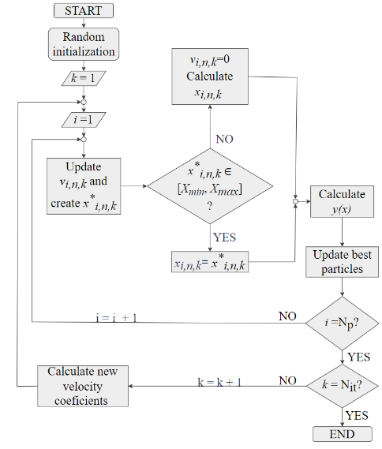

Figure 1. Particle Swarm Optimization algorithm.

References:
1. Nogueira, I.B.R., et al., Optimization of a True Moving Bed unit and determination of its feasible operating region using a novel Sliding Particle Swarm Optimization. Computers & Industrial Engineering, 2019. 135: p. 368-381. https://doi.org/10.1016/j.cie.2019.06.020.
2. Rebello, C.M., et al., From an Optimal Point to an Optimal Region: A Novel Methodology for Optimization of Multimodal Constrained Problems and a Novel Constrained Sliding Particle Swarm Optimization Strategy. Mathematics, 2021. 9(15). https://doi.org/10.3390/math9151808.
3. Rebello, C.M., et al., From a Pareto Front to Pareto Regions: A Novel Standpoint for Multiobjective Optimization. Mathematics, 2021. 9(24). https://doi.org/10.3390/math9243152.
4. Nogueira, I.B.R., et al., A novel nested loop optimization problem based on deep neural networks and feasible operation regions definition for simultaneous material screening and process optimization. Chemical Engineering Research and Design, 2022. 180: p. 243-253. https://doi.org/10.1016/j.cherd.2022.02.013.
5. Rebello, C.M., et al., A novel standpoint of Pressure Swing Adsorption processes multi-objective optimization: An approach based on feasible operation region mapping. Chemical Engineering Research and Design, 2022. 178: p. 590-601. https://doi.org/10.1016/j.cherd.2021.12.047.
6. Silva, B.C., et al., Metaheuristic Framework for Material Screening and Operating Optimization of Adsorption-Based Heat Pumps. ACS Omega, 2023. 8(22): p. 19874-19891. https://doi.org/10.1021/acsomega.3c01797.

