Supplementary Material
Decision Support Tool for Sustainable Small to Medium-Volume Natural Gas Utilization
Patience B. Shamaki ª*, Pedro H. Callil-Soares ª and Galo A. C. Le Roux ^{s}
ª University of São Paulo, Department of Chemical Engineering, Polytechnic School, São Paulo, Brazil
* Corresponding Author: shamakipatience@usp.br
S1 TOOL INPUT
The data for the natural gas profile used to test the model was obtained from the World Bank gas flaring tracker [1] as follows:

Table S1: Natural gas profile for rich Case Studies.
Location | SAU | USA | UK | NGA | AUS | BRA
Field | Gas | Oil | Oil | Rich | Lean | Lean
Volume
NG Composition
CH₄ | 55.5 | 58.7 | 69.4 | 90.12 | 87.5 | 81.57
C₂H₆ | 18 | 11.9 | 14.5 | 6.94 | 3.87 | 9.17
C₃H₈ | 9.8 | 10.3 | 9 | 2.09 | 1.34 | 5.13
C₄H₁₀ | 4.5 | 5.8 | 0.9 | 0.77 | 0.58 | 2.39
C₅H₁₂ | 1.3 | 5 |  | 0.079 | 0.44 | 0.83
C₆H₁₄₊ | 0.3 | 2.8 |  |  | 1.8
H₂O | 0.0 | 0.0
H₂S | 1.5 | 0.5
CO₂ | 8.9 | 0.9 | 4 |  | 1.68 | 0.39
N₂ | 0.2 | 0.0 | 2.7 |  | 2.79 | 0.52
O₂ | 0.0 | 0.0
CO | 0.0 | 1.0

S2 AN OVERVIEW OF THE APPLICATION
All source codes used for the development of the simple tool are available on the project’s github repository https://github.com/pedro-callil/flare-alternatives. The user interface for the utilization of the tool is presented:
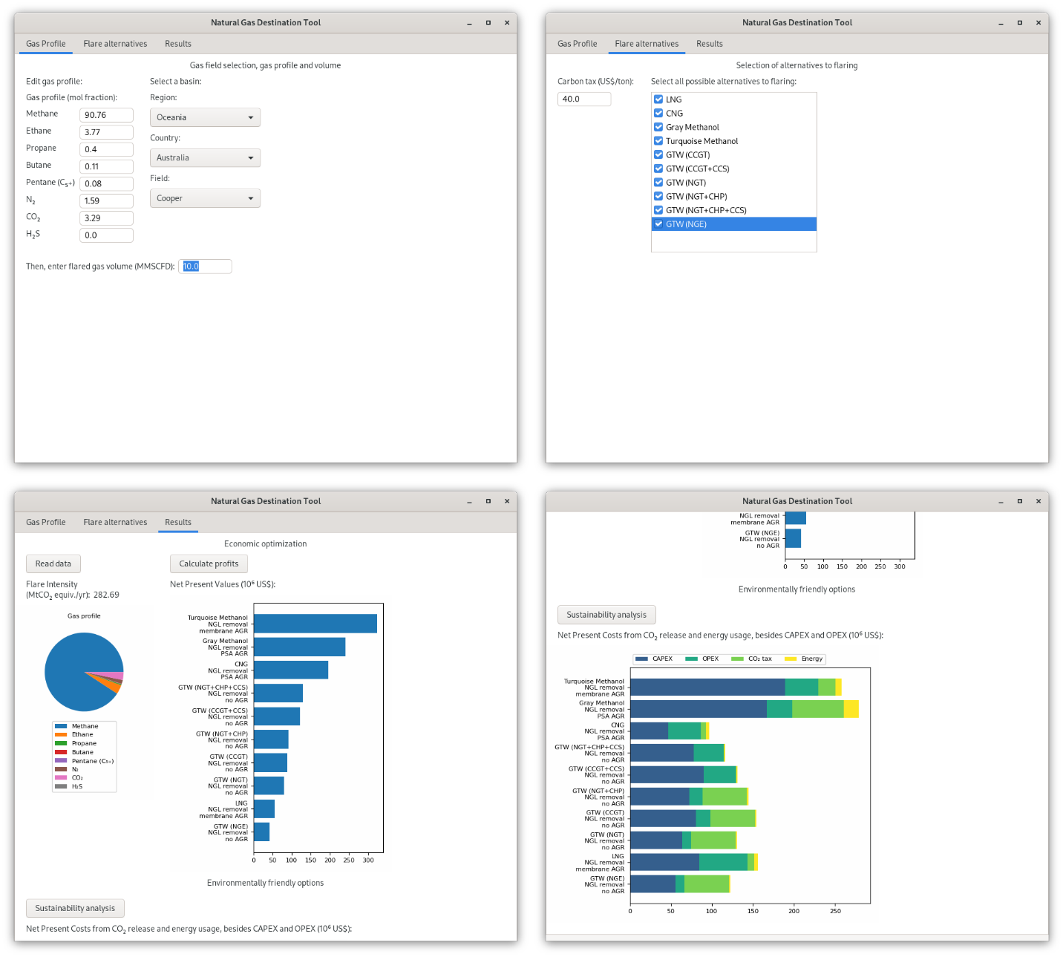
Figure S2. The graphical user interface for the simple decision making tool

