Closed-Loop Data-Driven Model Predictive Control For A Wet Granulation Process Of Continuous Pharmaceutical Tablet Production
Consuelo Del Pilar Vega Zambrano ª, Nikolaos A. Diangelakis ^{b}, and Vassilis M. Charitopoulos ª*
ª Department of Chemical Engineering, The Sargent Centre for Process Systems Engineering, University College London,
Torrington Place, London WC1E 7JE, UK
^{b} School of Chemical and Environmental Engineering, Technical University of Crete, Chania, Crete, GR 73100, Greece
* Corresponding Author: v.charitopoulos@ucl.ac.uk.

State-space models
$$x_{t+1}^{DMDc}=\left[\begin{matrix}1.3969 \\ 1.2208 \\ \begin{matrix}7.3777 \\ 37.2814 \end{matrix}\end{matrix} \begin{matrix}-0.2429 \\ 0.2527 \\ \begin{matrix}-4.3988 \\ -22.1905\end{matrix}\end{matrix} \begin{matrix}0.0051 \\ 0.0157 \\ \begin{matrix}1.0743 \\ 0.4578\end{matrix}\end{matrix} \begin{matrix}-0.0009 \\ -0.0030 \\ \begin{matrix}-0.0189 \\ 0.8995\end{matrix}\end{matrix}\right]x_{t}+\left[\begin{matrix}-0.0357 \\ -0.1098 \\ \begin{matrix}-0.6590 \\ -3.2398\end{matrix}\end{matrix} \begin{matrix}-0.0072 \\ -0.0220 \\ \begin{matrix} -0.1377 \\ -0.6833\end{matrix}\end{matrix} \begin{matrix}0.0691 \\ 0.2125 \\ \begin{matrix}1.3002 \\ 6.3171\end{matrix}\end{matrix} \right]u_{t}$$

$$x_{t+1}^{MOESP}=\left[\begin{matrix}1.6470 \\ 2.0112 \\ \begin{matrix}12.3140 \\ 63.7130\end{matrix}\end{matrix} \begin{matrix}0.6211 \\ 4.1550 \\ \begin{matrix}27.9170 \\ 95.4630\end{matrix}\end{matrix} \begin{matrix}-0.1038 \\ -0.4608 \\ \begin{matrix}-2.8015 \\ -13.9540\end{matrix}\end{matrix} \begin{matrix}-0.0109 \\ -0.0450 \\ \begin{matrix}-0.3523 \\ -0.3932\end{matrix}\end{matrix}\right]x_{t}+\left[\begin{matrix}-0.0216 \\ -0.0317 \\ \begin{matrix}0.0402 \\ -0.9756\end{matrix}\end{matrix} \begin{matrix}-0.0164 \\ -0.05655 \\ \begin{matrix}-0.3842 \\ -1.7405\end{matrix}\end{matrix} \begin{matrix}0.0909 \\ 0.2640 \\ \begin{matrix}1.5147 \\ 8.1148\end{matrix}\end{matrix} \right]u_{t}$$
$$x_{t+1}^{SINDyc}=\left[\begin{matrix}1.2341 \\ 1.1065 \\ \begin{matrix}7.3777 \\ 37.2814 \end{matrix}\end{matrix} \begin{matrix}-0.1684 \\ 0.1376 \\ \begin{matrix}-4.3988 \\ -22.1905\end{matrix}\end{matrix} \begin{matrix}0 \\ 0.0497 \\ \begin{matrix}1.0743 \\ 0.4578\end{matrix}\end{matrix} \begin{matrix}0 \\ 0 \\ \begin{matrix}-0.0189 \\ 0.8995\end{matrix}\end{matrix}\right]x_{t}+\left[\begin{matrix}-0.0265 \\ -0.1158 \\ \begin{matrix}-0.6590 \\ -3.2398\end{matrix}\end{matrix} \begin{matrix}-0.0061 \\ -0.0157 \\ \begin{matrix} -0.1377 \\ -0.6833\end{matrix}\end{matrix} \begin{matrix}0.0563 \\ 0.1954 \\ \begin{matrix}1.3002 \\ 6.3171\end{matrix}\end{matrix} \right]u_{t}$$

Uncertainty quantification for a state-space model:
Assuming the initial states follow a multivariate normal distribution with zero mean and covariance $Σ_{ε }$, we have:
$y_{t+1}=Ay_{t}+Bu_{t}+ε_{t+1},{ ε}_{t+1}∼N\left(0,Σ_{ε}\right)$ Eq. (1)
Where:
A: State transition matrix
B: Control input matrix.
$u_{t}$​: Control input at time t.
$ε_{t+1}∼N\left(0,Σ_{ε}\right)$ : Gaussian noise with covariance matrix $Σ_{ε}$
Based on the equivalence between the maximum likelihood estimator (MLE) of the Linear Mapping Matrix in a Linear State Space Model and the DMD estimation proposed by Gu et. al., 2024 we can find the covariance matrix $Σ_{ε}$ for a state-space model.
First, with n being the number of observed time points, the log-likelihood function $L\left(A,B,Σ_{ε}\right)$ is:
$L\left(A,B,Σ_{ε}\right)=\log\left(p\left(y\left(x_{1}\right)\right)\prod_{t=2}^{n}{p\left(y\left(x_{t}\right) | y\left(x_{t-1}\right),u\left(x_{t-1}\right),A,B,Σ_{ε}\right)}\right)$ Eq. (2)
Second, assuming the marginal distribution of the initial state $y\left(x_{1}\right)$ does not depend on A or B:
$L\left(A,B,Σ_{ε}\right)∝-\frac{n}{2}log\left(\left|Σ_{ε}\right|\right)-\frac{1}{2}\sum_{t=2}^{n}{{\left(y_{t}-Ay_{t-1}-Bu_{t-1}\right)}^{T}{Σ_{ε}}^{-1}\left(y_{t}-Ay_{t-1}-Bu_{t-1}\right)}$ Eq. (3)
$ε_{t}=y_{t}-Ay_{t-1}-Bu_{t-1}$ Eq. (4)
$L\left(A,B,Σ_{ε}\right)∝-\frac{n}{2}log\left(\left|Σ_{ε}\right|\right)-\frac{1}{2}\sum_{t=2}^{n}{{ε_{t}}^{T}{Σ_{ε}}^{-1}ε_{t}}$ Eq. (5)
Taking the derivative of log-likelihood with respect to A we obtain the maximum likelihood estimator $\hat{A}:$
$\frac{∂L}{∂A}= \sum_{t=2}^{n}{{Σ_{ε}}^{-1}ε_{t}(-{y_{t-1}}^{T}})$ Eq. (6)
$\sum_{t=2}^{n}{{Σ_{ε}}^{-1}\left(y_{t}-Ay_{t-1}-Bu_{t-1}\right)}{y_{t-1}}^{T}=0$ Eq. (7)
$\sum_{t=2}^{n}{{{y_{t}y}_{t-1}}^{T}-Ay_{t-1}{y_{t-1}}^{T}-Bu_{t-1}{y_{t-1}}^{T}}=0$ Eq. (8)
$\hat{A}=\left(\sum_{t=2}^{n}{{{y_{t}y}_{t-1}}^{T}}\right){\left(\sum_{t=2}^{n}{{{y_{t}y}_{t-1}}^{T}}\right)}^{-1}$ Eq. (9)

Taking the derivative of log-likelihood with respect to B we obtain the maximum likelihood estimator $\hat{B}:$
$\frac{∂L}{∂B}=\sum_{t=2}^{n}{{Σ_{ε}}^{-1}ε_{t}(-{u_{t-1}}^{T}})$ Eq. (10)
$\sum_{t=2}^{n}{{Σ_{ε}}^{-1}\left(y_{t}-Ay_{t-1}-Bu_{t-1}\right)}{u_{t-1}}^{T}=0$ Eq. (11)
$\sum_{t=2}^{n}{y_{t}{u_{t-1}}^{T}-Ay_{t-1}{u_{t-1}}^{T}-Bu_{t-1}{u_{t-1}}^{T}}=0$ Eq. (12)
$\hat{B}=\left(\sum_{t=2}^{n}{y_{t}{u_{t-1}}^{T}}\right){\left(\sum_{t=2}^{n}{y_{t}{u_{t-1}}^{T}}\right)}^{-1}$ Eq. (13)
Taking the derivative of log-likelihood with respect to $Σ_{ε}$ we obtain the maximum likelihood estimator$\hat{Σ}:$
$\frac{∂L}{∂Σ_{ε}}= -\frac{n}{2}{Σ_{ε}}^{-1}+\frac{1}{2}{Σ_{ε}}^{-1}\left(\sum_{t=2}^{n}{{ε_{t}}^{T}ε_{t}}\right){Σ_{ε}}^{-1}$ Eq. (14)
${\hat{Σ}}_{ε}=\frac{1}{n}\sum_{t=2}^{n}{{ε_{t}}^{T}}ε_{t}$ Eq. (15)
$If \frac{∂L}{∂Σ_{ε}}=0$with $Eq.4$:, the covariance matrix is:
${\hat{Σ}}_{ε}=\frac{1}{n}\sum_{t=2}^{n}{{\left(y_{t}-\hat{A}y_{t-1}-\hat{B}u_{t-1}\right)}^{T}}{ (y}_{t}-\hat{A}y_{t-1}-\hat{B}u_{t-1})=V\left[y_{\left(x_{t*}\right)}\right]$ Eq. (16)

To study how uncertainty propagates through time, the posterior covariance $V\left[\left.y_{t*+1}\right|Y,\hat{A},\hat{B},{\hat{Σ}}_{ε}\right]$for any $t^{*}>n$ is calculated following the law of total covariance and sampling Eq. (1):
$V\left[\left.y_{t*+1}\right|Y,\hat{A},\hat{B},{\hat{Σ}}_{ε}\right]=V\left[{\hat{A}y}_{t*}+{\hat{B}u}_{t*}+ε_{t*+1}\right]$ Eq. (17)
$V\left[{\hat{A}y}_{t*}+{\hat{B}u}_{t*}+ε_{t*+1}\right]=V\left[{\hat{A}y}_{t*}\right]+V\left[{\hat{B}u}_{t*}\right]+V\left[ε_{t*+1}\right]$ Eq. (18)
$V\left[\left.y_{t*+1}\right|Y,\hat{A},\hat{B},{\hat{Σ}}_{ε}\right]=\hat{A}V\left[y_{t*}\right]{\hat{A}}^{T}+\hat{B}V\left[u_{t*}\right]{\hat{B}}^{T}+Σ_{ε}$ Eq. (19)
By iterating this over multiple time steps,
$V\left[\left.y_{t*+1}\right|Y,\hat{A},\hat{B},{\hat{Σ}}_{ε}\right]=\sum_{i=0}^{t*-n}{{\hat{A}}^{i}{\hat{Σ}}_{ε}}{\left({\hat{A}}^{i}\right)}^{T}+\sum_{i=0}^{t*-n}{{\hat{A}}^{i}{\hat{B}\hat{Σ}}_{u}}{{\hat{B}}^{T}\left({\hat{A}}^{i}\right)}^{T}$ Eq. (20)
The control input covariance $V\left[u_{\left(x_{t*}\right)}\right]$ $={\hat{Σ}}_{u}$ is calculated as a diagonal matrix containing the standard deviations of each component of the control input vector (corresponding to input values of training data) because they are assumed to be independent of the others.
Lastly, the 95% confidence interval (CI) are calculated as:
$CI=y_{t*}±1.96⋅diag(V\left[\left.y_{t*}\right|Y,\hat{A},\hat{B},{\hat{Σ}}_{ε}\right]​)​$ Eq. (21)
Reference
Gu M, Lin Y, Lee VC, & Qiu DY. Probabilistic forecast of nonlinear dynamical systems with uncertainty quantification. Phys. D: Nonlinear Phenom., 457, 133938 (2024) https://doi.org/10.1016/j.physd.2023.133938

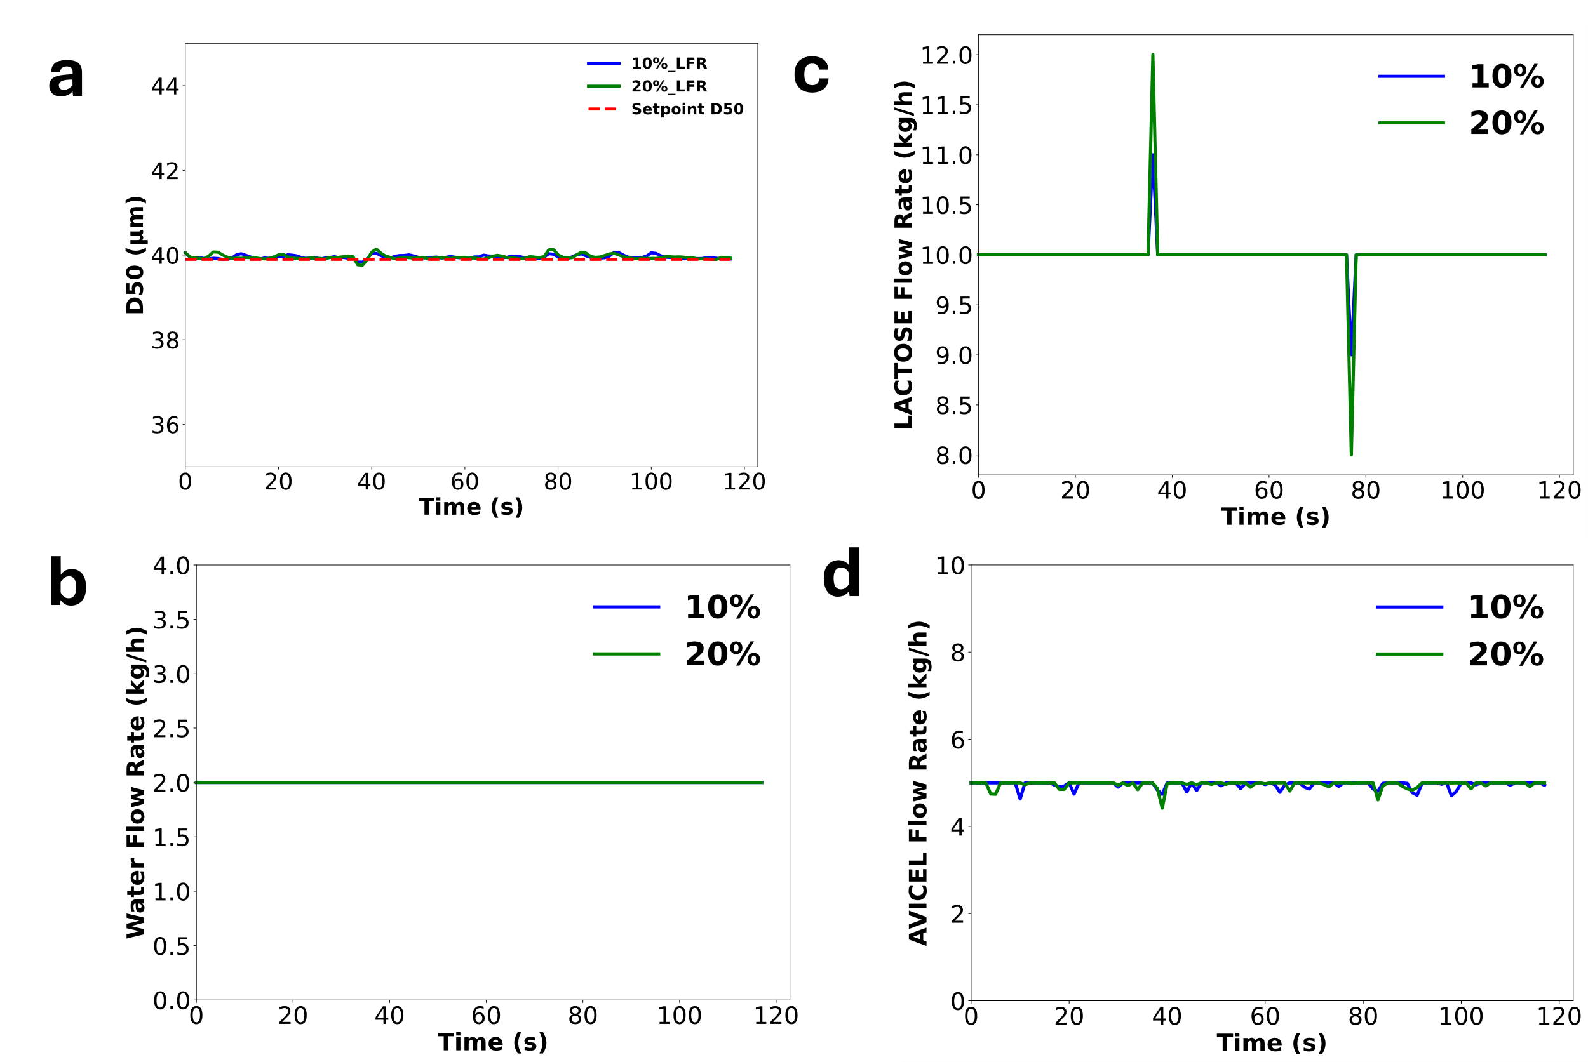

Supplementary Figure 1. MPC performance study. Lactose flowrate disturbance rejection. Results for controlled variable a. D50 and manipulated variables. b. BFR, c. LFR and d. AFR

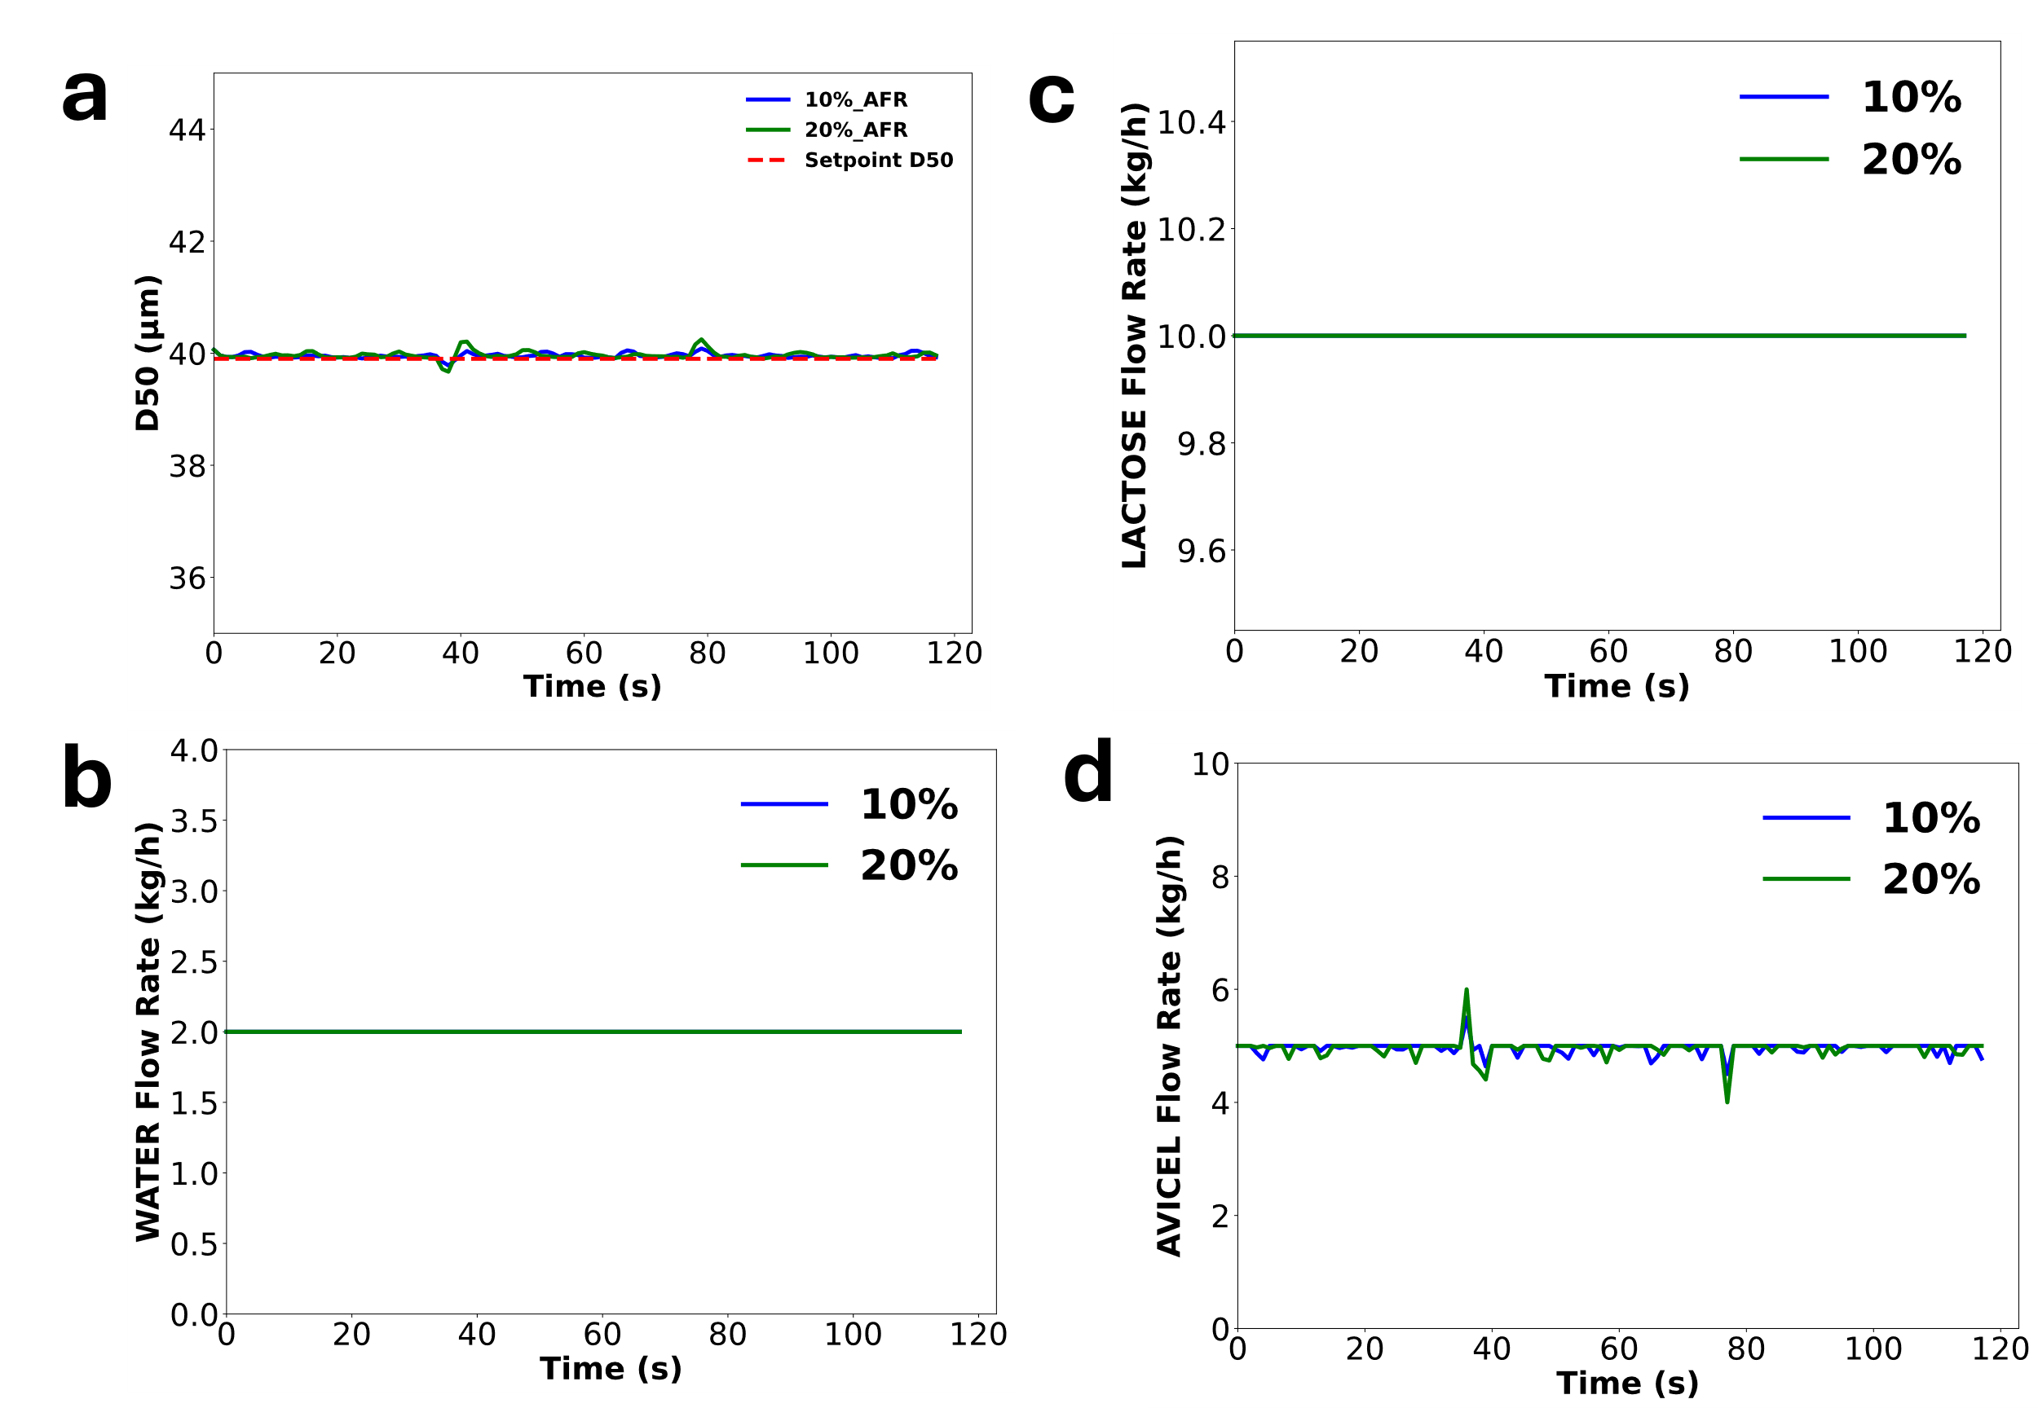

Supplementary Figure 2 MPC performance study. Avicel flowrate disturbance rejection. Results for controlled variable a. D50 and manipulated variables. b. BFR, c. LFR and d. AFR

